**Supplementary materials**

**Towards productivity-based management of corals reefs in the Anthropocene**

**Detailed Survey Methodology**

**Study Site**

**Sampling procedure**

**Detailed productivity framework to estimate growth rates and productivity**

First, for each individual we estimated the growth rate (K) using a database of 588 reef-associated fish species extracted from Fishbase and used by Morais and Bellwood, 2018 and MTE. The Metabolic Theory of Ecology (Brown *et al.*, 2004) states that body size and temperature jointly affect individual metabolic rate. Thus, the mass-specific growth rate can be written as follows (equation 1):

$K=K_{0}×M^{-β}×e^{-\frac{E_{α}}{k_{b}T}}$ (1)

Where M is species mass obtained from species maximum size and Length-Weight coefficients (know from life history traits), $β$ is the mass scaling coefficient (1/4 according to Brown *et al.*, 2004), $E_{α}$ the activation energy (around 0.65 according to Brown *et al.*, 2004) and $K_{0}$ a normalization constant. This equation can be linearized by log transformation (equation 2):

$\ln\left(K\right)=ln⁡(K_{0)}-β*\ln\left(M\right)*E_{α}*\frac{1}{k_{b}T}$ (2)

For individuals from a given species with measured growth rates in the database, we selected K measured with the closest temperature from our data and correct it with the following equation 3:

$K=K_{c}*e^{\frac{E_{α}}{k_{b}}×(\frac{1}{T_{c}}-\frac{1}{T})}$ (3)

Where growth rate $K_{c}$ is the observed growth rate at temperature $T_{c}$.

To estimates K from species for species for which we have no estimate of growth rate, we fitted linear mixed effect models between ln(K), ln(M) and $\frac{1}{k_{b}T}$ on observed growth database to obtain $M_{s}$ and $E_{a}$. We fitted different models with genus and family as random effects in order to obtain growth rate estimates at different taxonomic levels (genus if growth data exists for species of same genus, or else at family level).

Then, we use the following equation:

$K=K_{0}*M^{-M_{s}}*e^{-\frac{E_{a}}{k_{b}T}}$ (4)

The projected size of each individual at age t + x days was calculated using a derivation of the VBGF, following the procedure in Depczynski *et al.*, 2007;

$L_{t+x}=L_{inf}(1-e^{-k\left(T-t_{0}\right)})$ (5)

With t fish age at time of census, and theoretical age at L=0 (t0) and theoretical length at t=0 (L0) set to zero since we only focused on growth trajectories of adult fish.

In order to estimate the asymptotic length *Linf* of the LVB growth model, we fitted the proportionality relationship between *Linf* and *Lmax* by LME:

*Linf*  = A * *Lmax* (8)

Standing biomass of each survey assemblages is obtained from fish underwater surveys, and geometric. The body mass Mi of individual fish i can be obtained from its length, Li, through:

$M_{i}=a_{i}L_{i}^{bi}$ (9)

where $a_{i}$ and $b_{i}$ are species-specific power-law parameters with geometric properties, often referred to as length–weight parameters (Froese, 2006) and were extracted from Fishbase (TRUE?). Total standing biomass of the assemblage (of *n* individual fish masses) was calculated using the following equation:

$B=\sum_{i=1}^{n}{M_{i}}$ (10)

**Growth estimations**

Since biomass production and productivity are obtained by combining biomass with somatic growth, the first step is to estimate growth. However, growth is fuelled by metabolism and therefore varies according to mass and temperature [(Brown and Sibly, 2012)](https://www.zotero.org/google-docs/?q08FKB). In the case of fish, growth is generally described by the Von Bertalanffy Growth Function (VBGF), where the growth coefficient K is mainly correlated with body size and temperature; in the normal temperature range, growth rates generally decline with body mass, and increase with temperature. Individual growth rates determine the energy flux at the community level, leading to changes in biomass production. Thus, scaling growth rates for individuals in order to establish predictions at ecosystem levels is crucial. The Metabolic Theory of Ecology (MTE) states that any biological rates such as metabolic rate, oxygen consumption rate or growth rate vary predictably with body size and temperature [(Brown et al., 2004; Allen and Gillooly, 2009; Yvon-Durocher and Allen, 2012)](https://www.zotero.org/google-docs/?S1HtN5). Furthermore, the VBGF growth coefficient K follows the MTE rules so that the MTE can be used as the first step to estimate production and productivity [(Sibly et al., 2015)](https://www.zotero.org/google-docs/?QCkWGh).

Mixed-effect modelling of growth rates for 558 species with random effect at genus level revealed that the most parsimonious model included a random effect only for the mass scaling coefficient ß. The activation energy Ea showed no significant variation between genus, with an estimated fixed-effect value of Ea=-0.37 eV for all genus. The mass scaling coefficient ß varied between -0.07 to - 0.28 depending on genus, with fixed-effect value of -0.23. The model with random effect at family level showed similar results, with ß ranging from -0.13 to -0.25 among families (fixed effect = -0.23) and no significant variation of Ea among families (fixed effect = -0.47). The model at family level included a significant diet fixed effect, with higher growth for herbivore, carnivore, planktivores and then piscivores. We splitted our dataset into a training and testing dataset (80/20%) and ran linear regressions between predicted and observed values. Concerning the estimations of Linf, at family level, the proportionality coefficient between Linf and Lmax varied between 0.41 and 0.95. At genus level, this coefficient varied between 0.34 and 1.12. Using the metabolic theory of ecology, we estimated temperature and mass adjusted growth rates for reef associated fish species appearing in the 1780 UCV transects across New Caledonia. These estimations were made at genus, family or fish level according to available data.

For future analyses, our models will need to be improved, especially at family level, by using a larger database in order to better represent certain families/genus. Estimated values of ß, the mass scaling coefficient given by the slope between fish growth rates and the log of maximum mass, remained very close to and within the confidence intervals of the theoretical value of -0.25 predicted by metabolic scaling theory (fixed effect = -0.23) (West, Brown and Enquist, 1997, 2001; Brown and Sibly, 2012). This value also remained close to those reported in fish (Clarke, Johnston and Johnston, 2011; Sibly et al., 2015). Our activation energy, given by the slope between fish growth rates and 1/kT (fixed effect = 0.51), is less than the theoretical value of 0.65eV predicted by MTE (Gillooly et al., 2001; Brown et al., 2004). These studies focused on all species; in contrast, we focused on ectotherms, which may explain the difference between the two values.

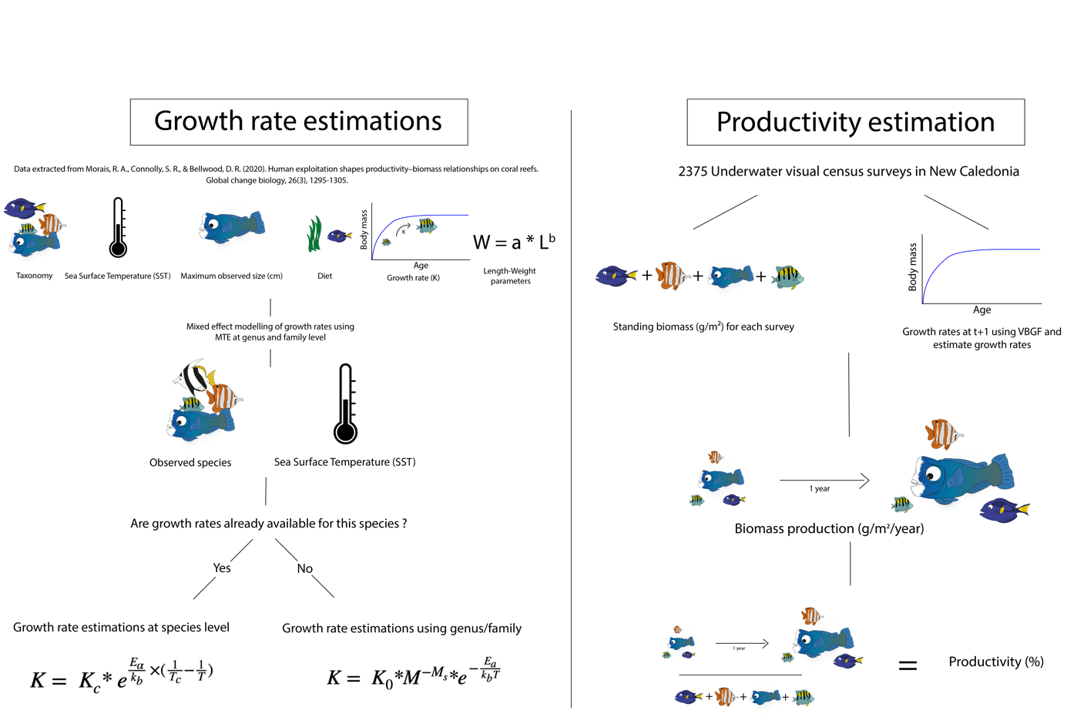

Figure 1 : Modelling framework to estimate growth rates using MTE and biomass production/productivity for our 6840 surveys. A MODIFIER

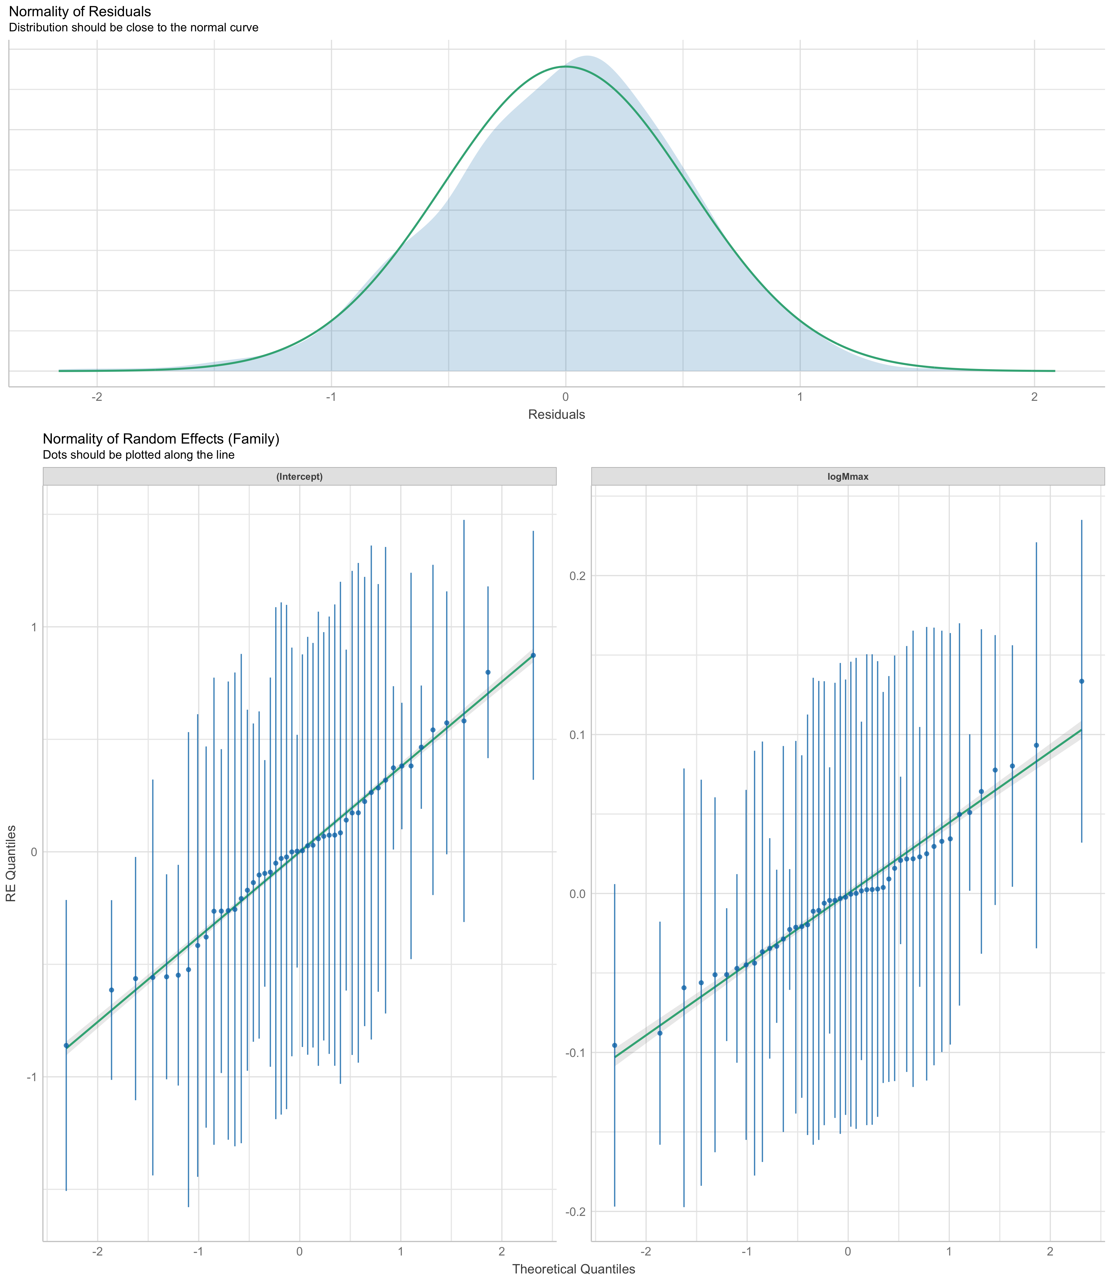Supplementary Figure X : Mixed effect model parameters



Supp Figure X : Low res for now

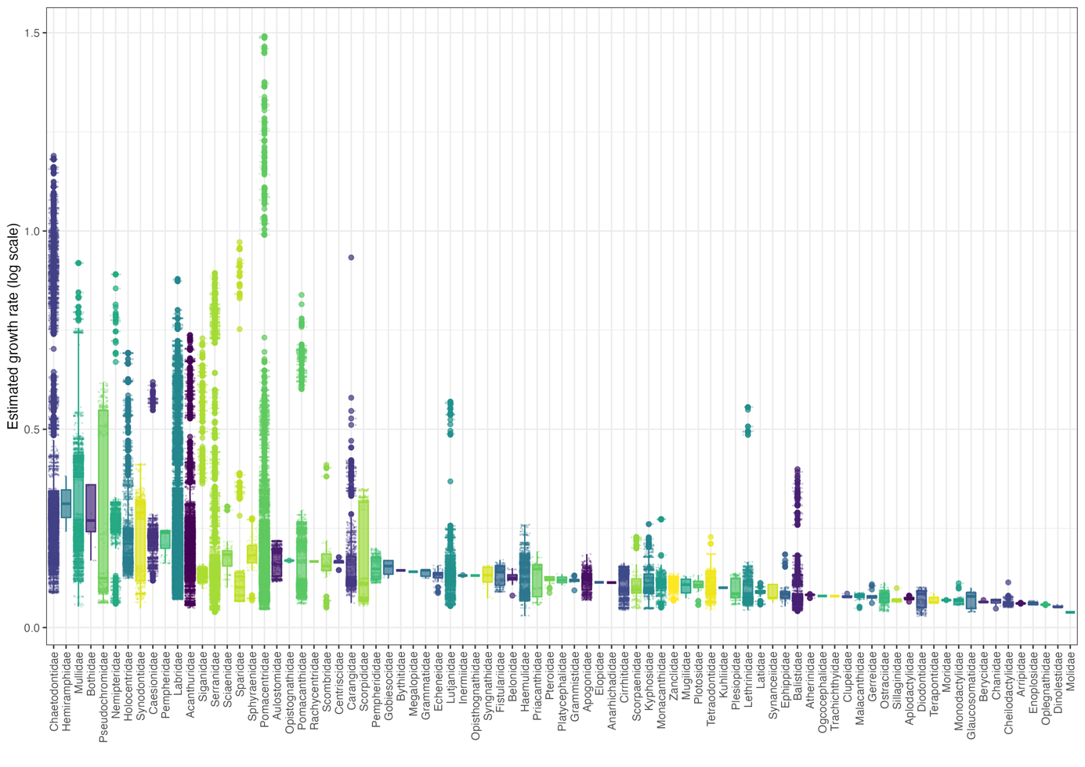

Supp Figure 2: Predicted growth rates for the 94 families.

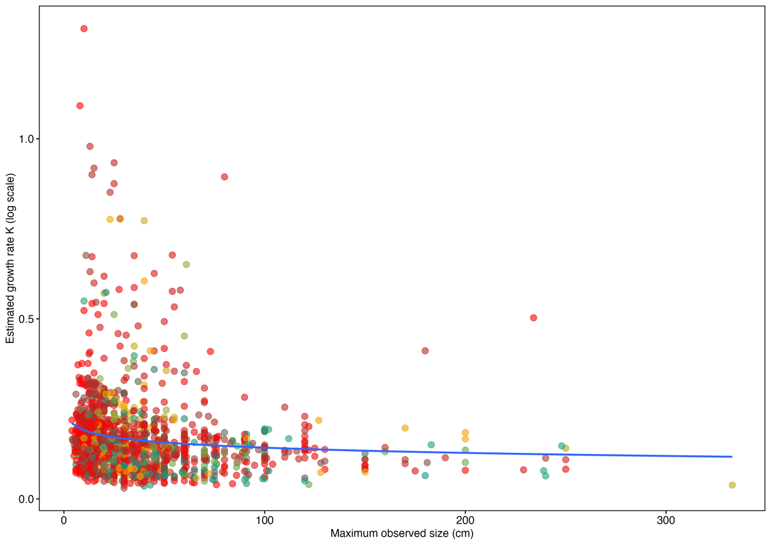

Supp Figure 3: Maximum observed size according to estimated growth rates for 94 families.

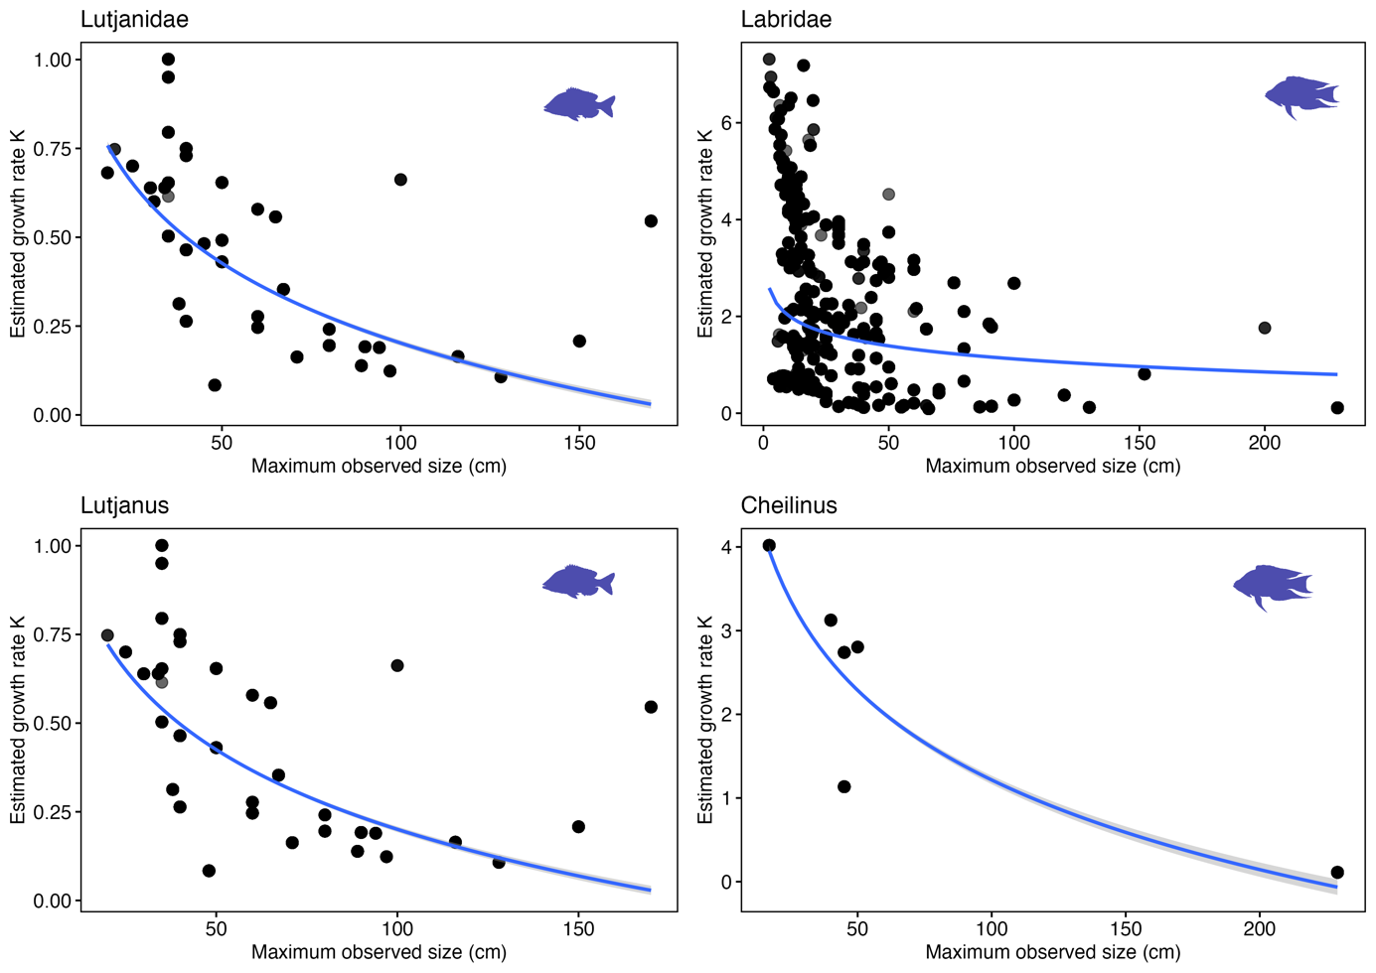

Supp Figure 4 : Maximum observed size (cm) according to estimated growth rates for two families (Lutjanidae and Labridae) and two genus (Lutjanus and Bodianus).

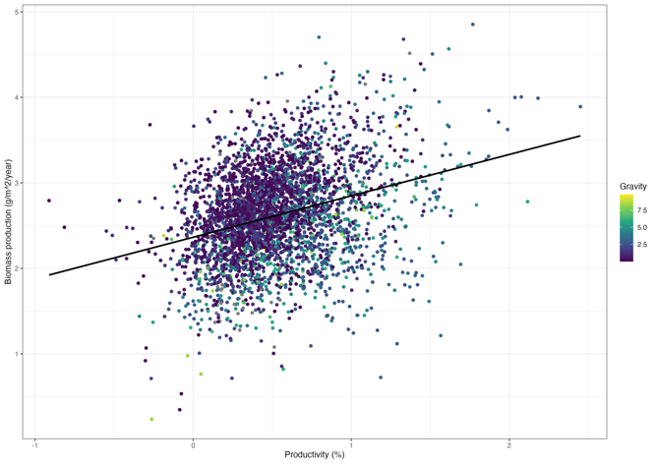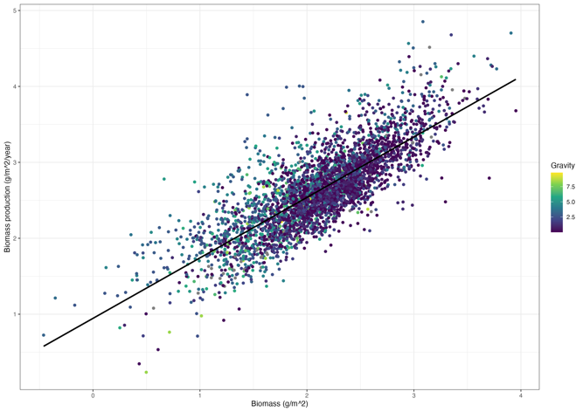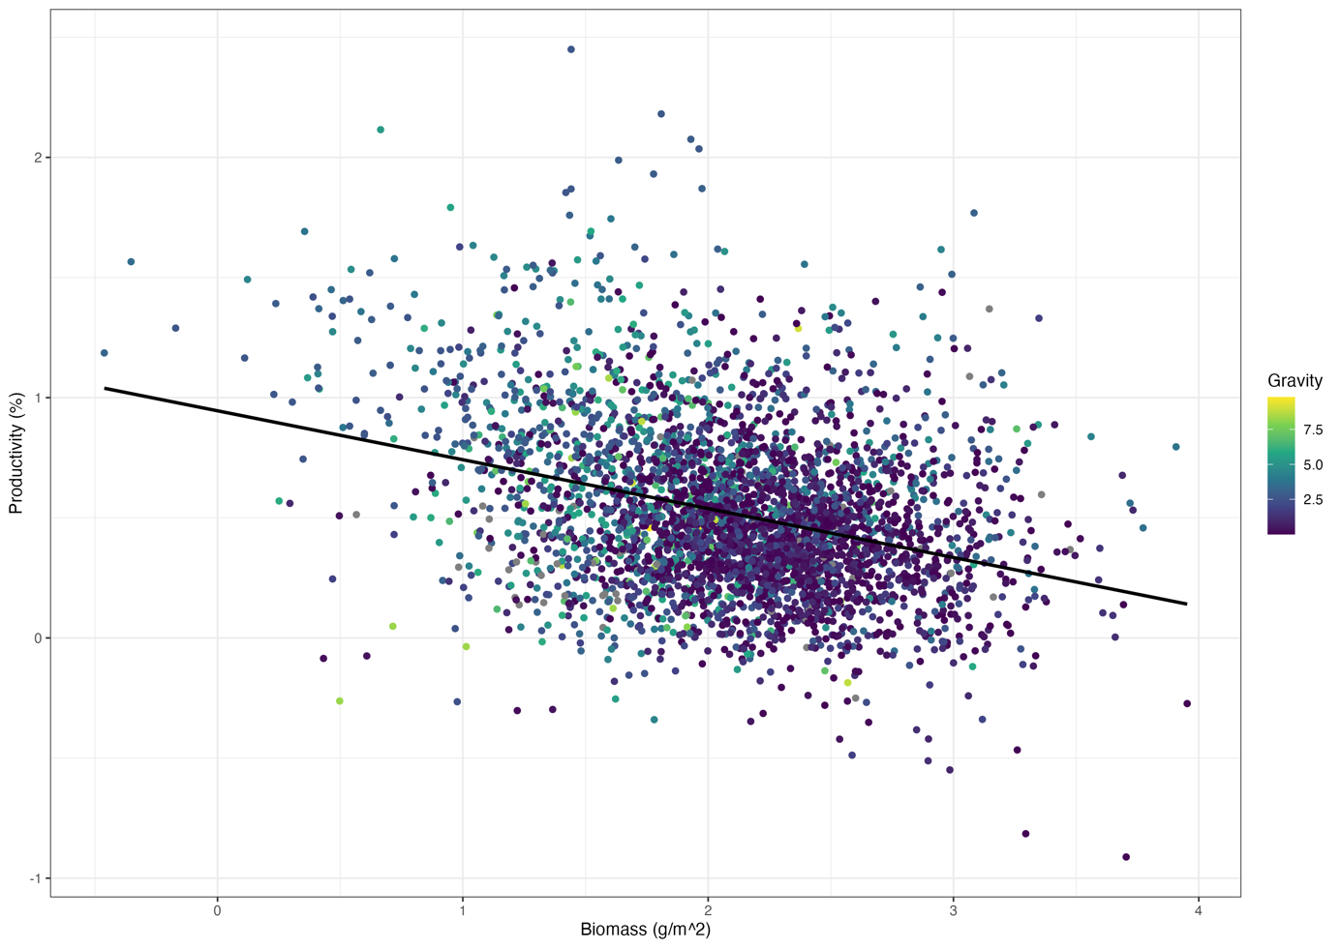

Supp Figure 5: Correlation between productivity and biomass production (R = 0.3), biomass production and standing biomass (R = 0.8) and productivity and biomass (R = -0.32)

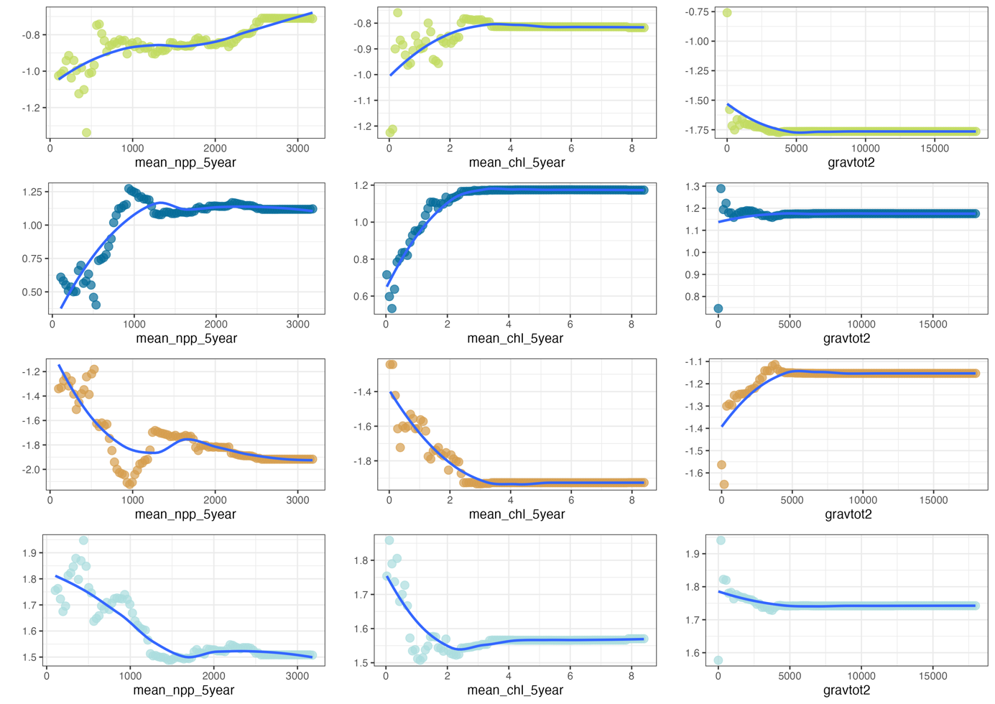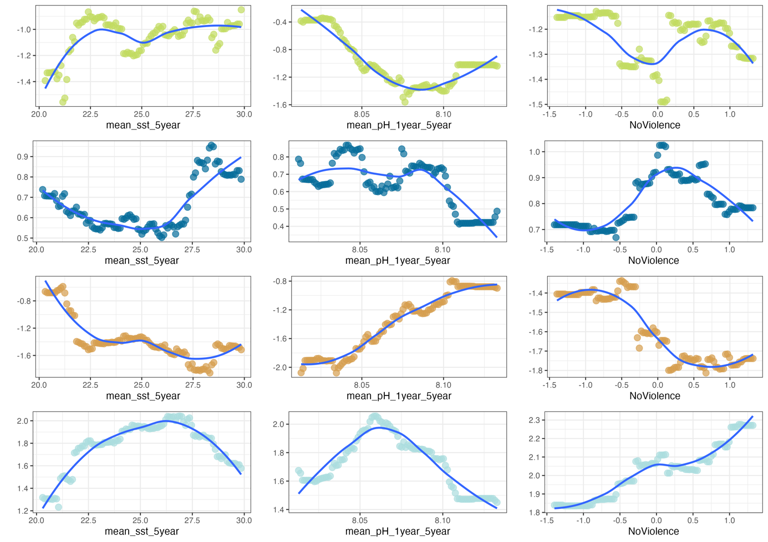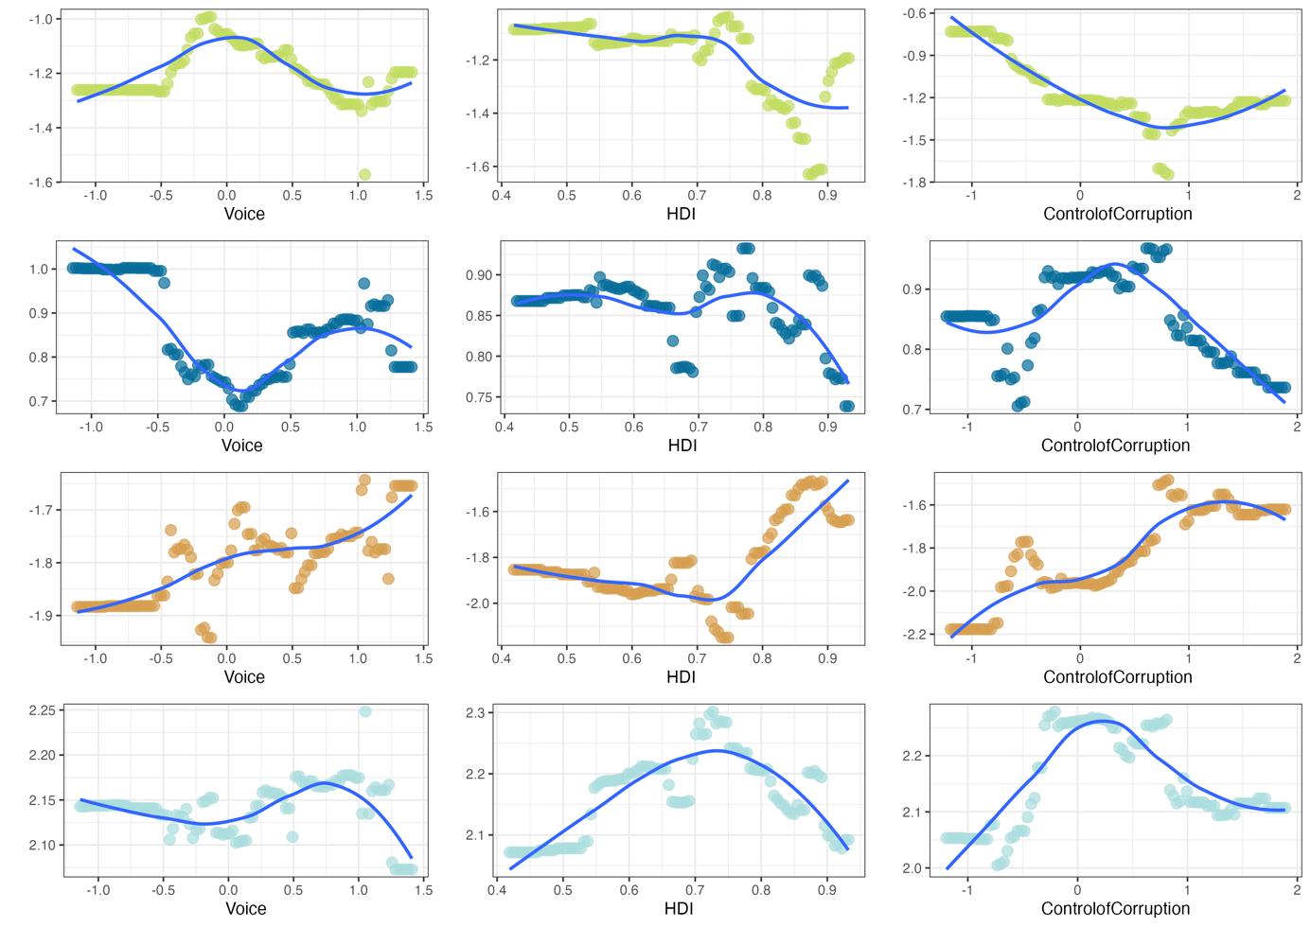

Supp Figure 6 : Partial dependence plots of predictor variables on classification probability of management classes

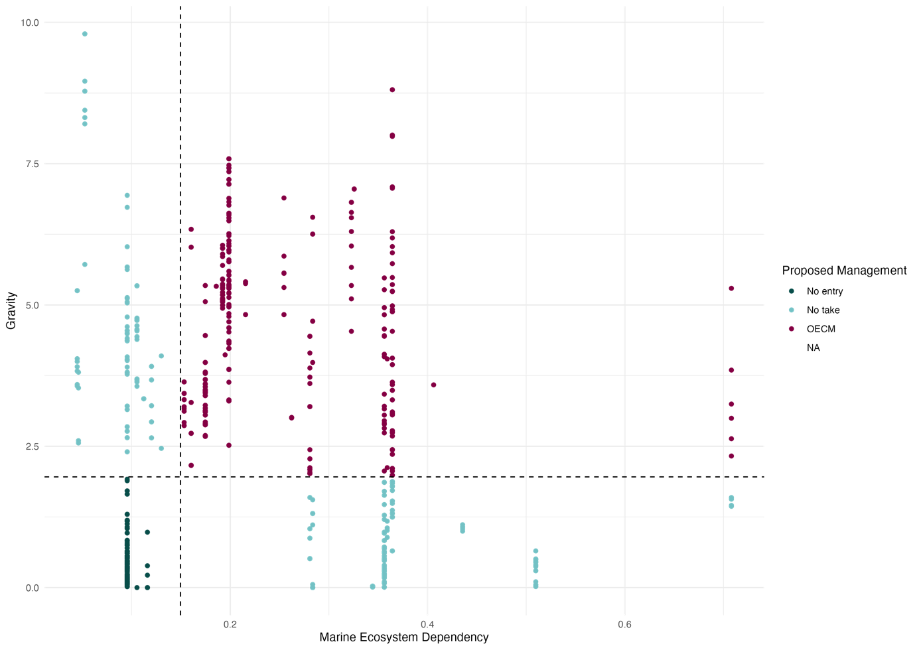

Supp Figure 6 : Management cut-off according to gravity and dependency on marine ecosystems

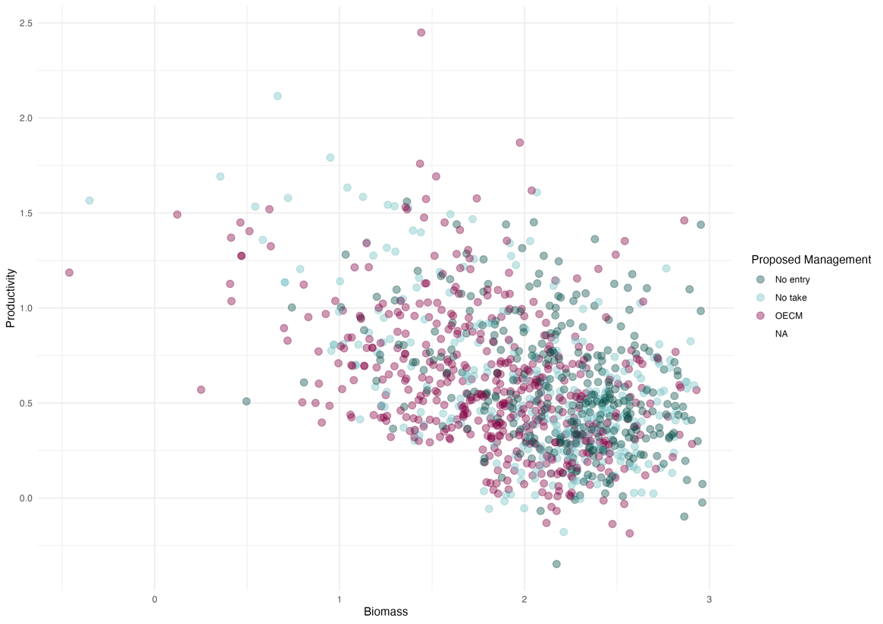

Supp Figure 7 : Proposed management according to cut-off on the biomass/productivity framework

Table 1 : Families (55) and genus (613) list for the 2120 species

|  |  |
| --- | --- |
| **Family** | **Genus** |
| Balistidae | Abudefduf |
| Balistidae | Acanthaluteres |
| Balistidae | Acanthemblemaria |
| Balistidae | Acanthistius |
| Balistidae | Acanthochromis |
| Scombridae | Acanthopagrus |
| Scombridae | Acanthostracion |
| Scombridae | Acanthurid |
| Scombridae | Acanthurus |
| Acanthuridae | Achoerodus |
| Acanthuridae | Actinopterygii |
| Acanthuridae | Aeoliscus |
| Acanthuridae | Aetapcus |
| Acanthuridae | Aethaloperca |
| Acanthuridae | Afurcagobius |
| Microdesmidae | Alectis |
| Carangidae | Alepes |
| Carangidae | Alloclinus |
| Carangidae | Alphestes |
| Carangidae | Aluterus |
| Carangidae | Amanses |
| Carangidae | Ambassis |
| Carangidae | Amblycirrhitus |
| Carangidae | Amblyeleotris |
| Gobiidae | Amblyglyphidodon |
| Gobiidae | Amblygobius |
| Gobiidae | Amblyrhynchotes |
| Gobiidae | Ammodytes |
| Gobiidae | Amphichaetodon |
| Batrachoididae | Amphiprion |
| Pomacentridae | Anampses |
| Pomacentridae | Anarrhichthys |
| Pomacentridae | Anisotremus |
| Haemulidae | Anoplocapros |
| Haemulidae | Anyperodon |
| Haemulidae | Aphareus |
| Lutjanidae | Aploactisoma |
| Lutjanidae | Aplodactylus |
| Apogonidae | Apogonid |
| Apogonidae | Apolemichthys |
| Apogonidae | Aprion |
| Apogonidae | Aracana |
| Tetraodontidae | Arothron |
| Tetraodontidae | Arripis |
| Arripidae | Artedius |
| Arripidae | Aseraggodes |
| Arripidae | Aspasmogaster |
| Arripidae | Aspidontus |
| Arripidae | Assessor |
| Arripidae | Assiculus |
| Arripidae | Asterorhombus |
| Gobiidae | Atherina |
| Gobiidae | Atherinid |
| Blenniidae | Atule |
| Blenniidae | Atypichthys |
| Blenniidae | Aulacocephalus |
| Blenniidae | Aulorhynchus |
| Blenniidae | Aulostomus |
| Blenniidae | Austrolabrus |
| Blenniidae | Axoclinus |
| Blenniidae | Balistapus |
| Blenniidae | Balistes |
| Blenniidae | Balistid |
| Blenniidae | Balistoides |
| Blenniidae | Bathygobius |
| Blenniidae | Bathystethus |
| Blenniidae | Belone |
| Blenniidae | Belonid |
| Blenniidae | Belonoperca |
| Blenniidae | Blenniella |
| Blenniidae | Blenniid |
| Blenniidae | Bodianus |
| Labridae | Bolbometopon |
| Labridae | Boops |
| Labridae | Boopsoidea |
| Labridae | Boreogadus |
| Labridae | Bothragonus |
| Labridae | Bothus |
| Labridae | Bovichtus |
| Labridae | Brachaluteres |
| Labridae | Brachyistius |
| Labridae | Bryaninops |
| Gobiidae | Caesio |
| Gobiidae | Caesionid |
| Gobiidae | Caesioperca |
| Gobiidae | Caesioscorpis |
| Gobiidae | Caffrogobius |
| Gobiidae | Calamus |
| Gobiidae | Callanthias |
| Gobiidae | Calliclinus |
| Gobiidae | Callionymid |
| Gobiidae | Callionymus |
| Gobiidae | Calloplesiops |
| Gobiidae | Calotomus |
| Tetraodontidae | Canthigaster |
| Tetraodontidae | Caprodon |
| Tetraodontidae | Caracanthus |
| Tetraodontidae | Carangid |
| Tetraodontidae | Carangoides |
| Tetraodontidae | Caranx |
| Carangidae | Caulolatilus |
| Carangidae | Centroberyx |
| Carangidae | Centrogenys |
| Carangidae | Centrolabrus |
| Carangidae | Centropogon |
| Carangidae | Centropyge |
| Pomacanthidae | Cephalopholis |
| Pomacanthidae | Cetoscarus |
| Chaetodontidae | Chaetodon |
| Chaetodontidae | Chaetodontoplus |
| Pomacanthidae | Champsocephalus |
| Pomacanthidae | Chanos |
| Labridae | Cheilinus |
| Labridae | Cheilio |
| Labridae | Cheilodactylus |
| Labridae | Cheilodipterus |
| Apogonidae | Cheiloprion |
| Apogonidae | Chelidonichthys |
| Apogonidae | Chelmon |
| Apogonidae | Chelmonops |
| Apogonidae | Chelon |
| Apogonidae | Chilomycterus |
| Apogonidae | Chirodactylus |
| Apogonidae | Chirolophis |
| Apogonidae | Chironemus |
| Chironemidae | Chlorurus |
| Scaridae | Choerodon |
| Labridae | Chromileptes |
| Labridae | Chromis |
| Pomacentridae | Chrysiptera |
| Pomacentridae | Chrysoblephus |
| Labridae | Cirrhilabrus |
| Labridae | Cirrhitichthys |
| Labridae | Cirrhitid |
| Labridae | Cirrhitops |
| Labridae | Cirrhitus |
| Labridae | Cirripectes |
| Labridae | Citharichthys |
| Labridae | Cleidopus |
| Labridae | Clepticus |
| Labridae | Clinid |
| Labridae | Clinus |
| Labridae | Clupeid |
| Labridae | Clupeiformes |
| Labridae | Cnidoglanis |
| Labridae | Cochleoceps |
| Labridae | Conger |
| Labridae | Congiopodus |
| Labridae | Congrid |
| Labridae | Coradion |
| Labridae | Coris |
| Labridae | Coryphopterus |
| Labridae | Corythoichthys |
| Syngnathidae | Cratinus |
| Syngnathidae | Creediid |
| Syngnathidae | Cremnochorites |
| Syngnathidae | Crenimugil |
| Syngnathidae | Cristiceps |
| Tripterygiidae | Crossosalarias |
| Tripterygiidae | Cryptichthys |
| Tripterygiidae | Cryptocentrus |
| Gobiidae | Ctenochaetus |
| Gobiidae | Ctenogobiops |
| Gobiidae | Ctenolabrus |
| Gobiidae | Cybiosarda |
| Gobiidae | Cyclichthys |
| Gobiidae | Cymatogaster |
| Gobiidae | Cymbacephalus |
| Gobiidae | Cypho |
| Pseudochromidae | Cyprinocirrhites |
| Pseudochromidae | Dactylophora |
| Pseudochromidae | Dactylopus |
| Pseudochromidae | Dascyllus |
| Pomacentridae | Decapterus |
| Carangidae | Dellichthys |
| Carangidae | Dendrochirus |
| Carangidae | Dentex |
| Carangidae | Dermatolepis |
| Carangidae | Diademichthys |
| Carangidae | Diagramma |
| Moronidae | Dicentrarchus |
| Moronidae | Dichistius |
| Moronidae | Dicotylichthys |
| Moronidae | Dinolestes |
| Moronidae | Diodon |
| Serranidae | Diplodus |
| Callionymidae | Diplogrammus |
| Callionymidae | Diploprion |
| Callionymidae | Diproctacanthus |
| Caesionidae | Dischistodus |
| Caesionidae | Doratonotus |
| Caesionidae | Dotalabrus |
| Syngnathidae | Echeneis |
| Syngnathidae | Echidna |
| Blenniidae | Ecsenius |
| Blenniidae | Ekemblemaria |
| Blenniidae | Elacatinus |
| Gobiidae | Elagatis |
| Gobiidae | Eleotrica |
| Gobiidae | Elops |
| Gobiidae | Embiotoca |
| Chaenopsidae | Enchelycore |
| Chaenopsidae | Engraulis |
| Chaenopsidae | Enneanectes |
| Chaenopsidae | Enneapterygius |
| Tripterygiidae | Enophrys |
| Tripterygiidae | Enoplosus |
| Tripterygiidae | Eocallionymus |
| Labridae | Epibulus |
| Labridae | Epinephelides |
| Serranidae | Epinephelus |
| Serranidae | Equetus |
| Serranidae | Eubalichthys |
| Serranidae | Eucinostomus |
| Serranidae | Eupetrichthys |
| Serranidae | Euthynnus |
| Serranidae | Eutrigla |
| Gobiidae | Eviota |
| Pentacerotidae | Exallias |
| Tripterygiidae | Forsterygion |
| Tripterygiidae | Furcina |
| Tripterygiidae | Fusigobius |
| Pomacanthidae | Genicanthus |
| Pomacanthidae | Genypterus |
| Pomacanthidae | Gerres |
| Gerreidae | Gibbonsia |
| Gerreidae | Girella |
| Gobiidae | Gobiodon |
| Gobiidae | Gobius |
| Gobiidae | Gobiusculus |
| Gobiidae | Gomphosus |
| Gobiidae | Goniistius |
| Congridae | Gracila |
| Congridae | Grahamina |
| Congridae | Gramma |
| Congridae | Grammatorcynus |
| Congridae | Grammistes |
| Microdesmidae | Gymnocaesio |
| Microdesmidae | Gymnocanthus |
| Microdesmidae | Gymnoclinus |
| Lethrinidae | Gymnocranius |
| Lethrinidae | Gymnocrotaphus |
| Lethrinidae | Gymnomuraena |
| Lethrinidae | Gymnosarda |
| Lethrinidae | Gymnothorax |
| Muraenidae | Haemulid |
| Muraenidae | Haemulon |
| Muraenidae | Haletta |
| Muraenidae | Halichoeres |
| Tripterygiidae | Helcogramma |
| Tripterygiidae | Helcogrammoides |
| Tripterygiidae | Helicolenus |
| Tripterygiidae | Hemiglyphidodon |
| Tripterygiidae | Hemigymnus |
| Tripterygiidae | Hemilepidotus |
| Congridae | Heteroconger |
| Congridae | Heteropriacanthus |
| Congridae | Heteroscarus |
| Congridae | Heterostichus |
| Congridae | Hexagrammos |
| Congridae | Hippocampus |
| Syngnathidae | Hipposcarus |
| Syngnathidae | Holacanthus |
| Syngnathidae | Holocentrus |
| Syngnathidae | Hologymnosus |
| Syngnathidae | Hoplolatilus |
| Malacanthidae | Hoplopagrus |
| Malacanthidae | Hyperlophus |
| Atherinidae | Hypoplectrodes |
| Atherinidae | Hypoplectrus |
| Atherinidae | Hyporhamphus |
| Atherinidae | Hypsurus |
| Atherinidae | Hypsypops |
| Atherinidae | Inermia |
| Atherinidae | Iniistius |
| Atherinidae | Inimicus |
| Atherinidae | Isocirrhitus |
| Atherinidae | Istigobius |
| Gobiidae | Itycirrhitus |
| Clupeidae | Johnrandallia |
| Clupeidae | Jordania |
| Clupeidae | Karalepis |
| Clupeidae | Koumansetta |
| Clupeidae | Kuhlia |
| Clupeidae | Kyphosus |
| Kyphosidae | Labracinus |
| Kyphosidae | Labrichthys |
| Kyphosidae | Labrid |
| Kyphosidae | Labrisomus |
| Kyphosidae | Labrisomid |
| Kyphosidae | Labroides |
| Kyphosidae | Labropsis |
| Labridae | Labrus |
| Labridae | Lachnolaimus |
| Labridae | Lactophrys |
| Labridae | Lactoria |
| Labridae | Larabicus |
| Labridae | Latridopsis |
| Labridae | Leiocottus |
| Labridae | Lepidonectes |
| Labridae | Lepidozygus |
| Labridae | Leptatherina |
| Labridae | Leptocottus |
| Labridae | Leptojulis |
| Labridae | Leptoscarus |
| Labridae | Lesueurigobius |
| Labridae | Lethrinid |
| Labridae | Lethrinus |
| Lethrinidae | Leviprora |
| Lethrinidae | Limnichthys |
| Lethrinidae | Liparis |
| Lethrinidae | Lipophrys |
| Lethrinidae | Lithognathus |
| Lethrinidae | Liza |
| Lutjanidae | Lutjanus |
| Lutjanidae | Luzonichthys |
| Serranidae | Lythrypnus |
| Serranidae | Macolor |
| Serranidae | Macrodontogobius |
| Serranidae | Macropharyngodon |
| Labrisomidae | Malacoctenus |
| Labrisomidae | Manonichthys |
| Labrisomidae | Maxillicosta |
| Labrisomidae | Mccoskerichthys |
| Labrisomidae | Mecaenichthys |
| Labrisomidae | Medialuna |
| Labrisomidae | Megalops |
| Labrisomidae | Meiacanthus |
| Blenniidae | Melichthys |
| Blenniidae | Mendosoma |
| Blenniidae | Meuschenia |
| Blenniidae | Microcanthus |
| Gobiidae | Microlepidotus |
| Gobiidae | Micropogonias |
| Gobiidae | Microspathodon |
| Gobiidae | Mola |
| Gobiidae | Molva |
| Gobiidae | Monacanthid |
| Gobiidae | Monacanthus |
| Gobiidae | Monodactylus |
| Gobiidae | Monotaxis |
| Gobiidae | Mugil |
| Gobiidae | Mugilid |
| Gobiidae | Mulloidichthys |
| Gobiidae | Mullus |
| Gobiidae | Muraena |
| Gobiidae | Mycteroperca |
| Gobiidae | Myoxocephalus |
| Gobiidae | Myrichthys |
| Gobiidae | Myripristis |
| Gobiidae | Nannosalarias |
| Gobiidae | Naso |
| Acanthuridae | Neatypus |
| Pomacentridae | Neoglyphidodon |
| Pomacentridae | Neomyxus |
| Pomacentridae | Neoniphon |
| Pomacentridae | Neoodax |
| Pomacentridae | Neopomacentrus |
| Pomacentridae | Neosebastes |
| Pomacentridae | Neosynchiropus |
| Pomacentridae | Nesogobius |
| Pomacentridae | Nexilosus |
| Pomacentridae | Nicholsina |
| Pomacentridae | Notocirrhitus |
| Pomacentridae | Notoclinops |
| Pomacentridae | Notoclinus |
| Pomacentridae | Notolabrus |
| Labridae | Novaculichthys |
| Labridae | Oblada |
| Labridae | Ocyurus |
| Labridae | Odax |
| Labridae | Odontoscion |
| Labridae | Odonus |
| Labridae | Ogcocephalus |
| Labridae | Ogilbyina |
| Labridae | Olisthops |
| Labridae | Omegophora |
| Labridae | Omobranchus |
| Labridae | Ophieleotris |
| Labridae | Ophioblennius |
| Labridae | Ophiodon |
| Labridae | Ophthalmolepis |
| Labridae | Opisthocentrus |
| Labridae | Opistognathus |
| Opistognathidae | Oplegnathus |
| Opistognathidae | Optivus |
| Opistognathidae | Orthonopias |
| Opistognathidae | Orthopristis |
| Apogonidae | Ostorhinchus |
| Apogonidae | Ostracion |
| Apogonidae | Othos |
| Apogonidae | Oxycercichthys |
| Apogonidae | Oxycheilinus |
| Labridae | Oxycirrhites |
| Labridae | Oxyjulis |
| Labridae | Oxylebius |
| Labridae | Oxymonacanthus |
| Labridae | Pachymetopon |
| Labridae | Pagellus |
| Labridae | Pagrus |
| Labridae | Parablennius |
| Lutjanidae | Paracaesio |
| Lutjanidae | Paracanthurus |
| Lutjanidae | Paracentropyge |
| Lutjanidae | Parachaetodon |
| Gobiidae | Parajulis |
| Gobiidae | Paralabrax |
| Serranidae | Paraluteres |
| Serranidae | Paramonacanthus |
| Serranidae | Paranotothenia |
| Serranidae | Paranthias |
| Serranidae | Parapercis |
| Pinguipedidae | Paraplesiops |
| Pinguipedidae | Paraplotosus |
| Pempheridae | Parapriacanthus |
| Pempheridae | Parapristipoma |
| Pempheridae | Parascolopsis |
| Pempheridae | Parascorpis |
| Pempheridae | Paratrachichthys |
| Pempheridae | Pareques |
| Pempheridae | Parequula |
| Microdesmidae | Paristiopterus |
| Pentacerotidae | Parma |
| Pomacentridae | Parupeneus |
| Mullidae | Patagonotothen |
| Mullidae | Pelates |
| Mullidae | Pelsartia |
| Mullidae | Pempheris |
| Mullidae | Pentaceropsis |
| Mullidae | Pentapodus |
| Nemipteridae | Pervagor |
| Nemipteridae | Petroscirtes |
| Nemipteridae | Phanerodon |
| Nemipteridae | Pholidapus |
| Pholidichthyidae | Pholis |
| Pholidichthyidae | Phycodurus |
| Gobiidae | Phyllopteryx |
| Gobiidae | Pictichromis |
| Gobiidae | Pictilabrus |
| Gobiidae | Pinguipes |
| Gobiidae | Plagiotremus |
| Gobiidae | Platax |
| Ephippidae | Platycephalid |
| Ephippidae | Platycephalus |
| Ephippidae | Plectorhinchus |
| Serranidae | Plectroglyphidodon |
| Serranidae | Plectropomus |
| Gobiidae | Pleurosicya |
| Plotosidae | Plotosus |
| Serranidae | Pollachius |
| Serranidae | Pomacanthid |
| Serranidae | Pomacanthus |
| Serranidae | Pomacentrid |
| Pomacentridae | Pomacentrus |
| Pomacentridae | Pomachromis |
| Pomacentridae | Pomadasys |
| Pomacentridae | Pomatomus |
| Pomacentridae | Pomatoschistus |
| Pomacentridae | Pontinus |
| Pomacentridae | Porichthys |
| Pomacentridae | Premnas |
| Pomacentridae | Priacanthus |
| Pomacentridae | Prionurus |
| Apogonidae | Pristiapogon |
| Apogonidae | Prognathodes |
| Apogonidae | Prolatilus |
| Apogonidae | Psammoperca |
| Serranidae | Pseudanthias |
| Serranidae | Pseudobalistes |
| Serranidae | Pseudoblennius |
| Serranidae | Pseudocaranx |
| Labridae | Pseudocheilinus |
| Labridae | Pseudochromid |
| Pseudochromidae | Pseudochromis |
| Pseudochromidae | Pseudocoris |
| Labridae | Pseudodax |
| Labridae | Pseudojuloides |
| Labridae | Pseudolabrus |
| Pleuronectidae | Pseudopleuronectes |
| Pleuronectidae | Pseudorhombus |
| Pleuronectidae | Pseudupeneus |
| Pleuronectidae | Pteragogus |
| Pleuronectidae | Ptereleotris |
| Pleuronectidae | Pterocaesio |
| Pleuronectidae | Pterogobius |
| Pleuronectidae | Pterogymnus |
| Pleuronectidae | Pterois |
| Pleuronectidae | Pygoplites |
| Pleuronectidae | Rachycentron |
| Pleuronectidae | Rastrelliger |
| Pleuronectidae | Remora |
| Pleuronectidae | Repomucenus |
| Pleuronectidae | Rhabdamia |
| Pleuronectidae | Rhabdosargus |
| Pleuronectidae | Rhacochilus |
| Pleuronectidae | Rhinecanthus |
| Pleuronectidae | Rhinesomus |
| Pleuronectidae | Rhinogobiops |
| Pleuronectidae | Rhinomuraena |
| Pleuronectidae | Rhombosolea |
| Pleuronectidae | Rhycherus |
| Pleuronectidae | Rhynchostracion |
| Tripterygiidae | Rypticus |
| Tripterygiidae | Salarias |
| Blenniidae | Salmo |
| Blenniidae | Sarda |
| Blenniidae | Sardina |
| Blenniidae | Sardinella |
| Blenniidae | Sardinops |
| Blenniidae | Sargocentron |
| Blenniidae | Sarpa |
| Blenniidae | Saurida |
| Blenniidae | Scaevius |
| Blenniidae | Scarid |
| Blenniidae | Scarus |
| Scaridae | Schuettea |
| Scaridae | Sciaena |
| Scaridae | Scobinichthys |
| Scaridae | Scolecenchelys |
| Scaridae | Scolopsis |
| Nemipteridae | Scomber |
| Carangidae | Scomberoides |
| Carangidae | Scomberomorus |
| Scombridae | Scombrid |
| Scombridae | Scombrops |
| Scombridae | Scorpaena |
| Scorpaenidae | Scorpaenodes |
| Scorpaenidae | Scorpaenopsis |
| Scorpaenidae | Scorpis |
| Scorpaenidae | Sebastapistes |
| Scorpaenidae | Sebastes |
| Sebastidae | Sebastiscus |
| Sebastidae | Sectator |
| Sebastidae | Selar |
| Sebastidae | Selaroides |
| Sebastidae | Selene |
| Sebastidae | Semicossyphus |
| Sebastidae | Seriola |
| Sebastidae | Seriolella |
| Sebastidae | Serranid |
| Sebastidae | Serranocirrhitus |
| Sebastidae | Serranus |
| Serranidae | Siganus |
| Siganidae | Signigobius |
| Siganidae | Sillaginodes |
| Siganidae | Sillago |
| Siganidae | Siphamia |
| Apogonidae | Siphonognathus |
| Apogonidae | Solea |
| Apogonidae | Soleid |
| Solenostomidae | Sparid |
| Solenostomidae | Sparisoma |
| Solenostomidae | Sparodon |
| Apogonidae | Sphoeroides |
| Apogonidae | Sphyraena |
| Sphyraenidae | Sphyraenid |
| Sphyraenidae | Spicara |
| Sphyraenidae | Spondyliosoma |
| Clupeidae | Spratelloides |
| Clupeidae | Squamicreedia |
| Clupeidae | Stanulus |
| Clupeidae | Stegastes |
| Pomacentridae | Stephanolepis |
| Pomacentridae | Stethojulis |
| Syngnathidae | Strongylura |
| Syngnathidae | Stygnobrotula |
| Syngnathidae | Suezichthys |
| Syngnathidae | Sufflamen |
| Labridae | Symphodus |
| Labridae | Symphorichthys |
| Labridae | Symphorus |
| Labridae | Synanceia |
| Callionymidae | Synchiropus |
| Synodontidae | Synodus |
| Apogonidae | Taenianotus |
| Tetraodontidae | Taurulus |
| Labridae | Tautogolabrus |
| Labridae | Tetractenos |
| Labridae | Thalassoma |
| Labridae | Thamnaconus |
| Labridae | Thorogobius |
| Labridae | Threpterius |
| Labridae | Thunnus |
| Labridae | Thyrsites |
| Labridae | Thysanophrys |
| Labridae | Tilodon |
| Labridae | Torquigener |
| Labridae | Trachichthys |
| Labridae | Trachinops |
| Carangidae | Trachinotus |
| Carangidae | Trachinus |
| Carangidae | Trachurus |
| Carangidae | Trachypoma |
| Diodontidae | Trianectes |
| Diodontidae | Tridentiger |
| Gobiidae | Trimma |
| Gobiidae | Trinorfolkia |
| Gobiidae | Tripterygiid |
| Gobiidae | Tripterygion |
| Gadidae | Trisopterus |
| Gadidae | Tylosurus |
| Muraenidae | Valenciennea |
| Gobiidae | Variola |
| Gobiidae | Vincentia |
| Gobiidae | Xanthichthys |
| Gobiidae | Xenocys |
| Gobiidae | Xyrichtys |
| Pentacerotidae | Zanclus |
| Pentacerotidae | Zebrasoma |
| Pentacerotidae | Zeugopterus |
| Zeidae | Zoarces |
| Zeidae | Zoarchias |
| Apogonidae | Zoramia |